The difficult conversations are the ones you need to have

**IABC Leadership Institute, San Diego – Catherine Ducharme, Presenter**

Being a leader at work, or in a volunteer capacity, is not easy. Your responsibility as a leader is to achieve results by guiding your team through many conversations, including difficult ones. While guidance is the building block of leadership, giving critical feedback is profoundly uncomfortable for most people so we avoid it.

**What are some of the situations that arise in running an IABC Chapter/Board that may require a difficult conversation?**

________________________________________________________________________

________________________________________________________________________

________________________________________________________________________

________________________________________________________________________

________________________________________________________________________

**Why do we avoid having difficult conversations? What’s going on?**

________________________________________________________________________

________________________________________________________________________

________________________________________________________________________

________________________________________________________________________

________________________________________________________________________

**What are the benefits to having a difficult conversation?**

________________________________________________________________________

________________________________________________________________________

________________________________________________________________________

________________________________________________________________________

________________________________________________________________________

**Reframe Difficult Conversations**

Rather than seeing a difficult conversation as a reprimand, confrontation or something negative, we need to view it as an investment in another person. How are we investing?

* Helping them grow and develop so they can build expertise
* Ensuring they have the tools and clarity of expectations so they can succeed
* Increasing self-awareness by shining the light on blind spots that may hold them back
* Protecting a person’s reputation as they build their career
* An opportunity to learn from failure

It is your job as a leader to invest in people and have the difficult conversations. By not having open, candid conversations, you rob people of the opportunity to fix the problem, improve and succeed.

**The best conversations are radically candid**

Kim Scott, author of the book, *Radical Candor*, defines radical candour as **caring personally** and **challenging directly**.

**Caring personally**

* Build genuine, trusting relationships with your team
* Care enough about them to develop them
* Assure – confidentiality, safe space
* Be curious and listen well – ask questions to understand what is going on
* Empathize – share when you’ve been in a similar situation
* State your intentions – I want to help you/support you/develop you/invest in you

**Challenge directly**

* Say what needs to be said to help your team members be the best they can be
* Get to the point quickly
* Be clear
* Be factual and specific – talk about what was said or observed
* Don’t personalize – point to behaviour not character
* Highlight the impact

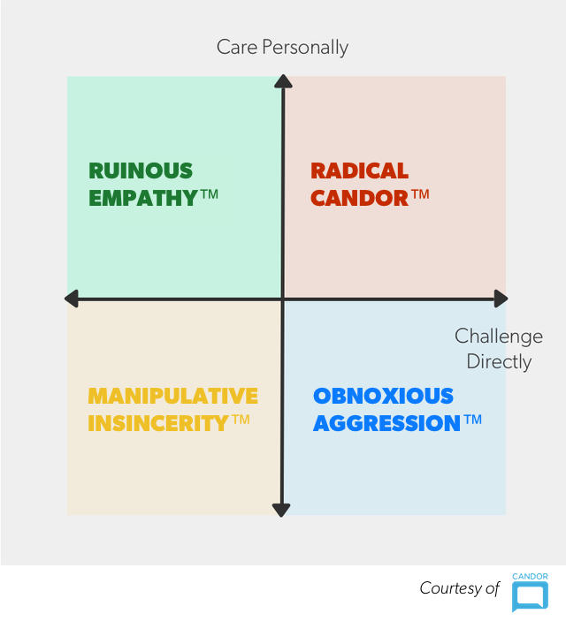

**The most difficult conversation of all – firing someone**

Probably the most difficult conversation we avoid is firing someone. This should never be done in haste without a lot of thought. It’s highly personal and could be emotionally charged. But you can’t let it linger too long. Before making the decision, you need to ask yourself:

1. Have you given the person radical, candid guidance?
2. Do you understand how this person is impacting the rest of the team (by the time you learn about it, has the person has been driving the team nuts for a long time)?
3. Have you sought advice from others? Get a second opinion from someone you trust and with whom you can talk the problem through to ensure you are being fair.
4. Have you done this before? What support can you get to help yourself?

**Lies we tell ourselves**

* They are a volunteer, we can’t fire them
* It will get better, I just have to give it more time
* Somebody is better than nobody (we are challenged by finding volunteers)
* It’s bad for morale
* I don’t want to be the jerk who could damage this person’s reputation

Failing to deal with a performance issue is not fair to the rest of the team because they have to pick up the slack which can overburden them.

**Tips when parting ways**

* Be clear, but compassionate (radical candor)
* Always give the opportunity to resign rather being fired. It gives them some control.
* Provide assurance that details will not be discussed
* Be clear on whether or not you will or will not provide a reference

**Difficult Conversations Openers**

* You know I’m a big fan and want to support your development. We need to talk about…
* I need to have a conversation that may be difficult and uncomfortable, but I’m confident we can work through it.
* Know this is coming from a place of caring about you. Here’s the situation…
* There’s no easy way to say this so I’m just going to jump in.

*Catherine Ducharme is Chair of the IABC Canada West Region and past President of IABC/BC. She is also a leadership performance coach and trainer with Smart Savvy & Associates, a people performance company based in Vancouver, British Columbia.*